

Semester Two Examination, 2022
Question/Answer booklet

MATHEMATICS
METHODS
UNIT 1&2
Section One:
Calculator-free

Your name

Your Teacher’s name

Number of additional
answer booklets used
(if applicable):

Time allowed for this section

Reading time before commencing work: five minutes
Working time: fifty minutes

Materials required/recommended for this section
To be provided by the supervisor
This Question/Answer booklet
Formula sheet

To be provided by the candidate
Standard items: pens (blue/black preferred), pencils (including coloured), sharpener,
correction fluid/tape, eraser, ruler, highlighters

Special items: drawing instruments, templates, notes on two unfolded sheets of A4 paper, are permitted in this course examination

Important note to candidates
No other items may be taken into the examination room. It is your responsibility to ensure that you do not have any unauthorised material. If you have any unauthorised material with you, hand it to the supervisor before reading any further.

Structure of this paper

Section | Number of  questions  available | Number of  questions to  be answered | Working  time  (minutes) | Marks  available | Percentage  of  examination
Section One:  Calculator-free | 12 | 12 | 50 | 51 | 35
Section Two:  Calculator-assumed | 13 | 13 | 100 | 100 | 65
 |  |  |  | Total | 100

Instructions to candidates
Markers use only
Question | Maximum | Mark
1 | 3
2 | 4
3 | 3
4 | 2
5 | 3
6 | 5
7 | 3
8 | 4
9 | 5
10 | 4
11 | 6
12 | 9
S1 Total | 51
S1 Wt (×0.35) | 35%

1. The rules for the conduct of examinations are detailed in the school handbook. Sitting this examination implies that you agree to abide by these rules.

2. Write your answers in this Question/Answer booklet preferably using a blue/black pen.
Do not use erasable or gel pens.

3. You must be careful to confine your answers to the specific question asked and to follow any instructions that are specific to a particular question.

4. Show all your working clearly. Your working should be in sufficient detail to allow your answers to be checked readily and for marks to be awarded for reasoning. Incorrect answers given without supporting reasoning cannot be allocated any marks. For any question or part question worth more than two marks, valid working or justification is required to receive full marks. If you repeat any question, ensure that you cancel the answer you do not wish to have marked.

5. It is recommended that you do not use pencil, except in diagrams.

6. Supplementary pages for planning/continuing your answers to questions are provided at the end of this Question/Answer booklet. If you use these pages to continue an answer, indicate at the original answer where the answer is continued, i.e. give the page number.

7. The Formula sheet is not to be handed in with your Question/Answer booklet.

Section One: Calculator-free 35% (51 Marks)
This section has twelve questions. Answer all questions. Write your answers in the spaces provided.

Working time: 50 minutes.

Question 1 (1.1.21) (3 marks)

Determine the centre and radius of the circle with equation $x^{2}+y^{2}-6y=0$.

Question 2 (1.1.17) (4 marks)

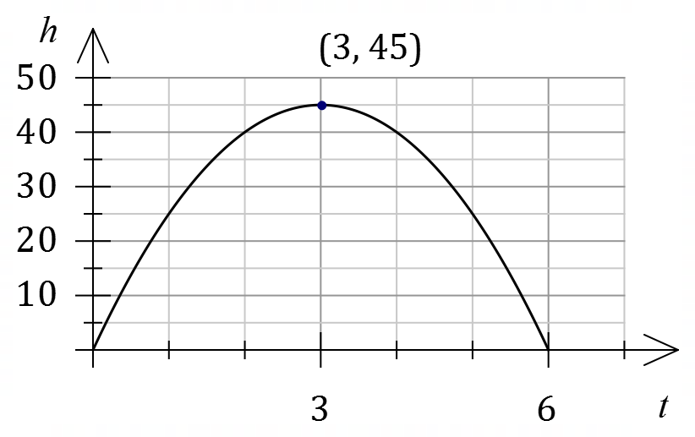
(b) The height $h$ metres above the ground
of a small body $t$ seconds after it is
projected vertically upwards is shown
in the position-time graph.

Given that $h=at^{2}+bt$, where $a$ and $b$
are constants, determine the speed of
the body when $t=0.9$.

Question 3 (1.1.16) (3 marks)
Solve the equation $4\cos^{2}\left(\begin{matrix}x \\ \overline{2}\end{matrix}\right)-3=0$ for $0≤x≤2π$.

Question 4 (2.1.1, 2.1.2) (2 marks)
(a) Determine $f\left(2\right)$ in simplified form when $f\left(x\right)={25}^{1.5-x}$.

Question 5 (1.1.5) (3 marks)

(a) The tangent to the curve $y=f(x)$ at $(3, -2)$ is perpendicular to the tangent to the same curve at point $P$. Determine the equation of the tangent at $P$. (3 marks)

Question 6 (1.3.1 – 1.3.5) (5 marks)

(a) State whether the following are True or False. (3 marks)

(i) 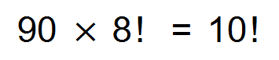 __________

(ii) 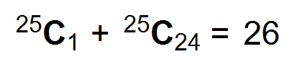 __________

(iii) 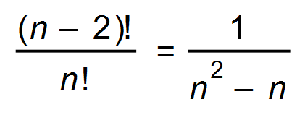 __________

(b) Determine the 5th term in the expansion of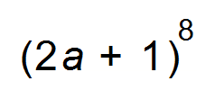. (2 marks)

Question 7 (2.1.1, 2.1.3) (3 marks)

(a) Simplify the following, leaving your solution in scientific notation rounded to 2 significant figures:
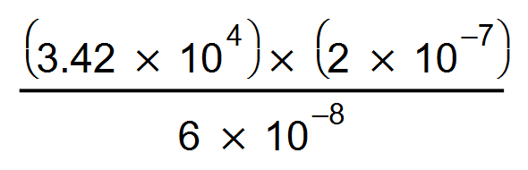

Question 8 (1.2.9,1.2.10,1.2.12) (4 marks)

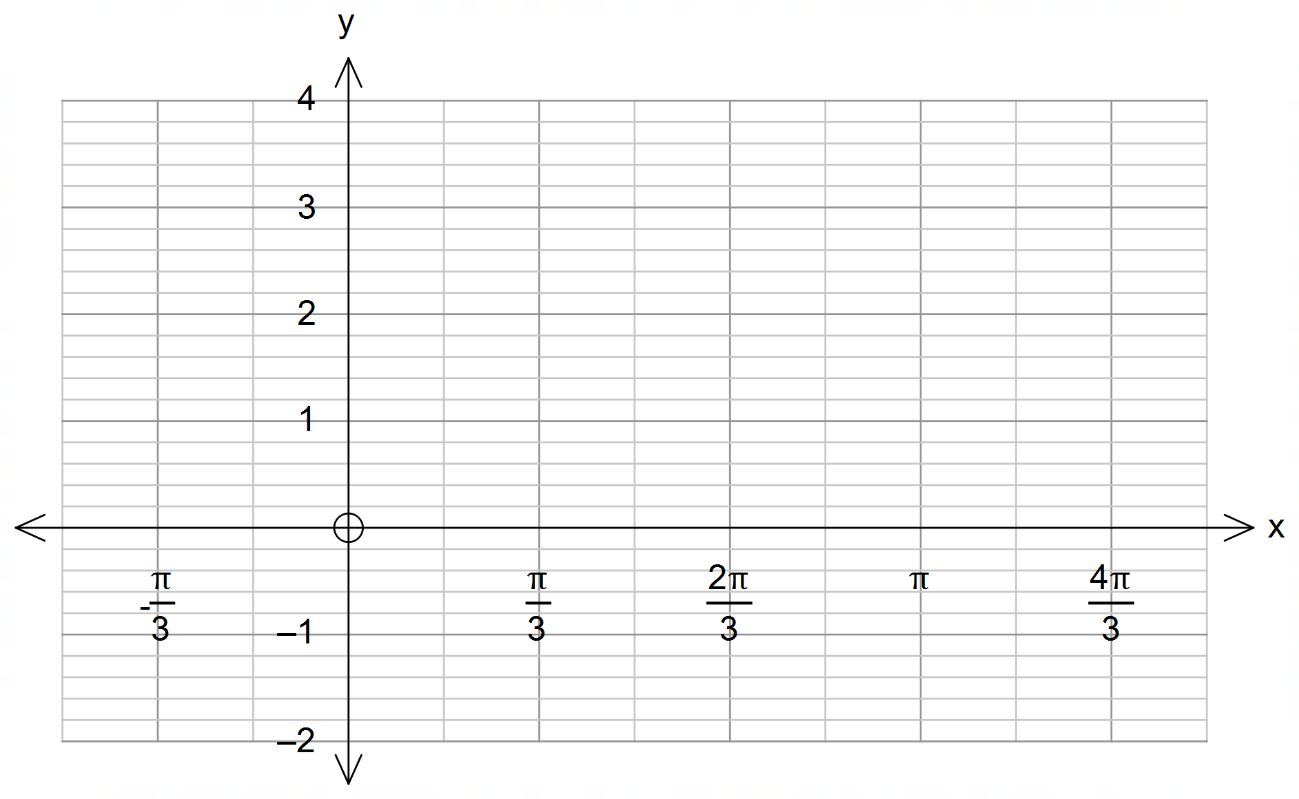(b) (i) Draw the graph of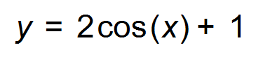over the domain 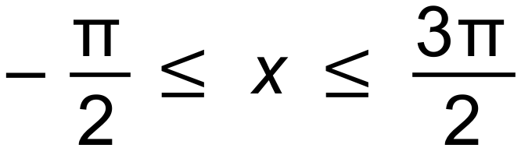 on the axes below.
(2 marks)

(ii) State the co-ordinates of the stationary points of the function on the given domain.
(2 marks)

Question 9 (2.3.15, 2.3.22) (5 marks)

- Determine 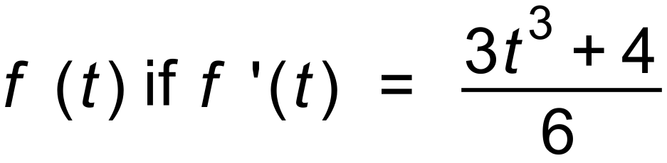 (2 marks)

(b)

Determine the function if the point (−1, 4) lies on the graph of the function. (3 marks)

Question 10 (1.1.1 – 1.1.5) (4 marks)

Two sides of a square are formed by the lines

$$y=3x+2$$
$$3y+x-6=0$$

One of the corners of the square is at $\left(0, 2\right).$

(a) Explain why these two lines intersect at $(0, 2)$. (1 mark)

Another of the corners is the $x$-intercept of $3y+x-6=0.$

(b) Determine the coordinates of this corner. (1 mark)

A third corner is found at $(2, 8)$ on the line $y=3x+2$.

(c) Given that the diagonals of a square bisect each other determine the coordinates of the fourth corner. (2 marks)

Question 11 (1.1.13, 1.1.14, 1.1.15, 1.1.26) (6 marks)

The dashed hyperbola $y=\frac{1}{x+2}$ is drawn below.

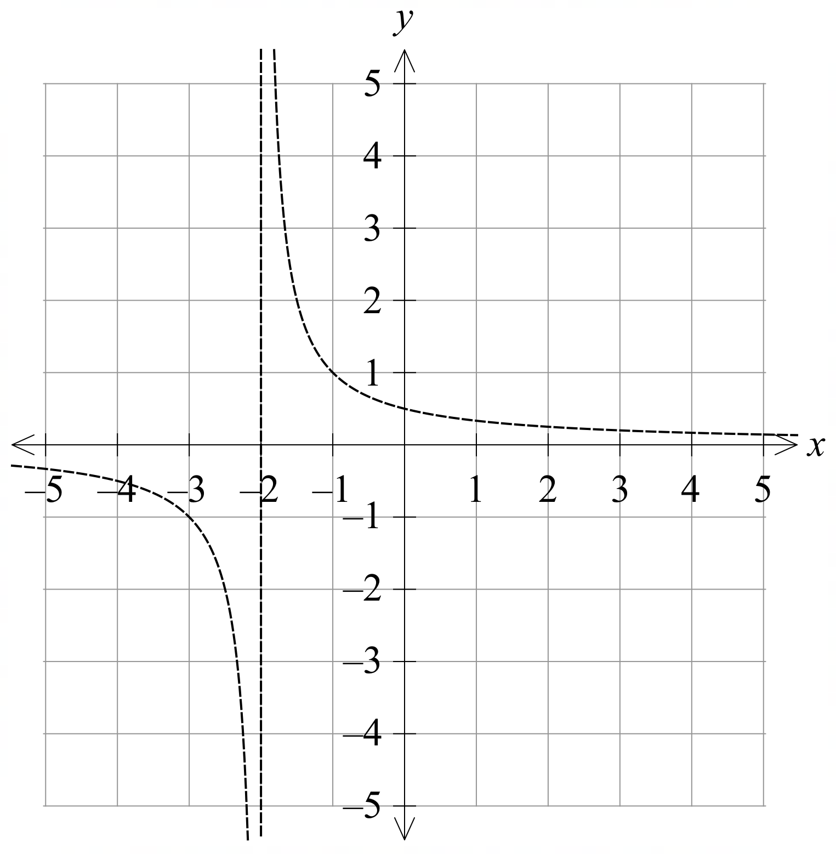

(a) The graph is translated horizontally $3$ units right, and $1$ unit up.
Draw the translated graph on the axes above. (2 marks)

(b) State the equation of the translated hyperbola, and show that the hyperbola
passes through the origin. (2 marks)

A student claims that the section of the graph in part (a) in the first quadrant could present an inverse proportion relationship.

(c) Is this student correct? Justify your answer either algebraically or graphically. (2 marks)

Question 12 (1.2.4, 1.2.7, 1.2.8,1.2.14) (9 marks)

(a) Using sine rule, or otherwise, explain why the triangle drawn below cannot exist. (3 marks)

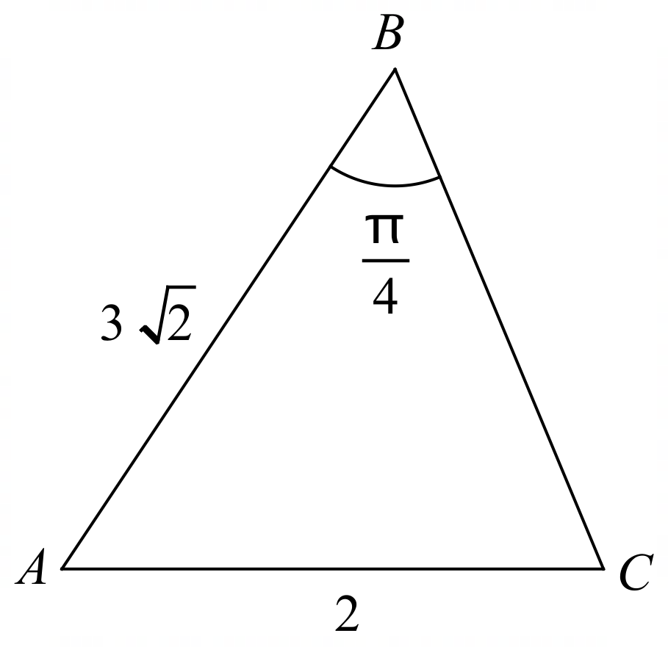

(b) Given $\sin{A}=\frac{1}{5}$, where $A$ is in the first quadrant, and $\cos{B}=\frac{2}{3}$, where $B$ is in the fourth quadrant.
(i) Determine the exact value of $\sin{(A+B)}.$ (4 marks)

(ii) Determine which quadrant is $A+B$ in, justifying your answer. (2 marks)

Supplementary page

Question number: _________

Supplementary page

Question number: _________

